Storage account ZRS storage account EUS

Script :

New-AzStorageAccount -ResourceGroupName Casestudy-EastUS `

-Name euszrs1 `

-Location eastus `

-SkuName Standard_ZRS `

-Kind StorageV2

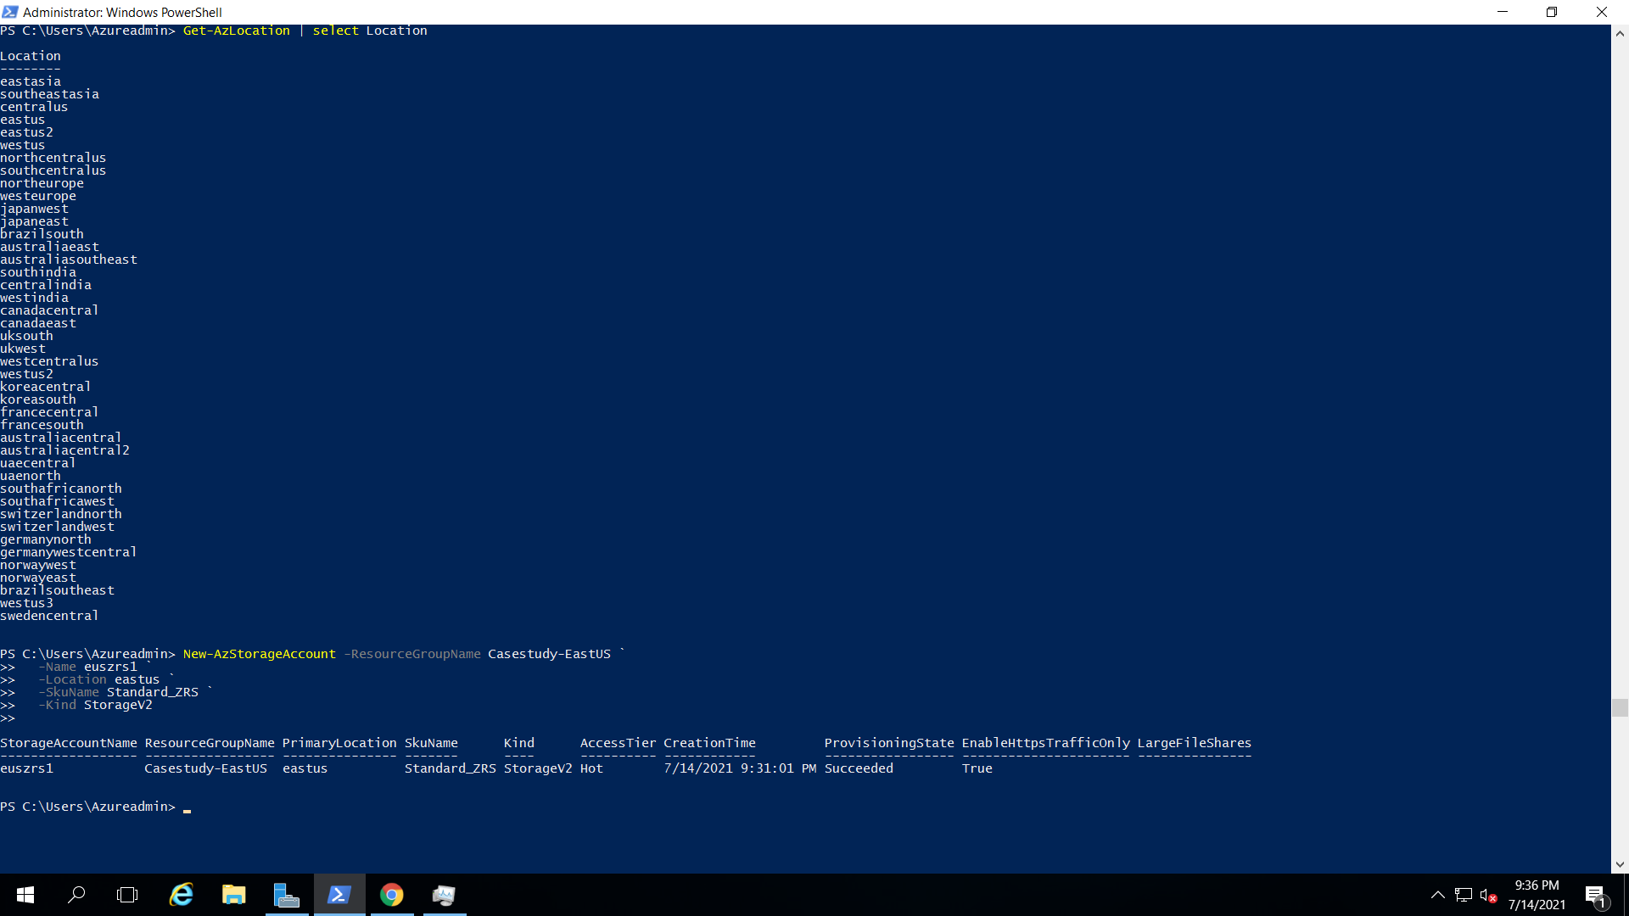

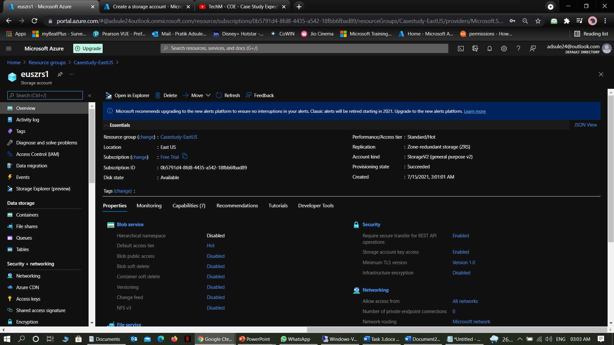

Storage Account GRS for SEA region

New-AzStorageAccount -ResourceGroupName Casestudy-SEA `

-Name seagrs1 `

-Location southeastasia `

-SkuName Standard_GRS `

-Kind StorageV2

